Unit 7 Assignment
Name:Joseph Angelo O. Japitana Date: 11/4/2026
Year and Section: BSIT 3-B
Note: Upload your Flutter project to your assigned folder here -> https://github.com/WVSU-BSIT-Batch-2028/CC-207B_26-27_Activities. Read the instructions on submitting, including the file name/folder conventions in the GitHub repository.

I. CICT Org Fair App Development part 3.
It is the day before the Org Fair and it starts to rain. Pixel Arts Guild cancels its Photo Walk, and CSC moves its Hour of Code to the gym. In Part 2 every event lived in fair_data.dart, so each change meant editing Dart, rebuilding and asking every student to update the app.
In this activity, the events move into a Content Management System (CMS) that you choose. Org officers write and publish events in the CMS admin panel, and the app reads them through the CMS's API. You will choose and set up the CMS, finish 11 small pieces of code, explain how they work, and run experiments that show what a CMS changes (and what can still go wrong).
Get the initial Flutter project source code from: https://github.com/WVSU-BSIT-Batch-2028/CC-207B_26-27_Samples/tree/main/Unit%207

Do the following steps to accomplish this assignment:

- Choose your CMS. Pick one of the three headless CMSs below. The starter has a source class for each, so the app code is the same size whichever you choose. What differs is the setup, the URL and the shape of the JSON.

 | Strapi | Contentful | Sanity
Type | Headless, open source | Headless, hosted (SaaS) | Headless, hosted (SaaS)
Setup | Runs on your computer: npx create-strapi@latest (needs Node.js) | Website only, nothing to install | npm create sanity@latest makes an editor (Studio); fields are written in code
Cost | Free (self-hosted) | Free plan | Free plan
The app needs | Server URL (+ token if Public cannot read) | Space ID + Content Delivery token | Project ID (+ dataset, token if private)
Watch out | For Unit 8 the server must be online, not on localhost (e.g. Strapi Cloud) | Empty fields are left out of the JSON | For web, add your app's address to CORS origins

Answer the following questions based on the CMS you’ve chosen:
- (1 point) Who will edit your content?
The Org officers will, they don’t even need to be developers. They just need to write and publish events in Contentful’s web editor, no need for them to touch the code or build the app.
- (1 point) Do you have a server?
No. Contentful is hosted, so it stores the content and serves the API for us.
- (1 point) Is there already a website?
No. Flutter is only the front end and it reads the events through Contentful’s API.
- (2 point) Do users create data?
No. Students only read events. Only officers create and change them in the CMS.

- Model the content. Create one content type for events in your CMS. The names must match exactly (capital letters too), because the app reads them by name.
Field | Strapi type | Contentful type | Sanity type | Example
title | Text (short) | Short text | string | Hour of Code
orgId | Text (short) | Short text | string | csc
startsAt | Date (datetime) | Date and time | datetime | Nov 8, 2026, 1:00 PM
venue | Text (short) | Short text | string | CICT Lab 2
description | Text (long) | Long text | text | No experience needed.
cancelled | Boolean | Boolean | boolean | false

Content type name: Strapi display name "Fair Event" (the API ID becomes fair-event, and the URL uses fair-events); Contentful content type ID fairEvent; Sanity schema type name fairEvent. In Strapi, use Text (long), not Rich text: Rich text sends blocks, not a String.
- Provide a screenshot of the content you’ve created in your CMS. (5 points)
Screenshot:
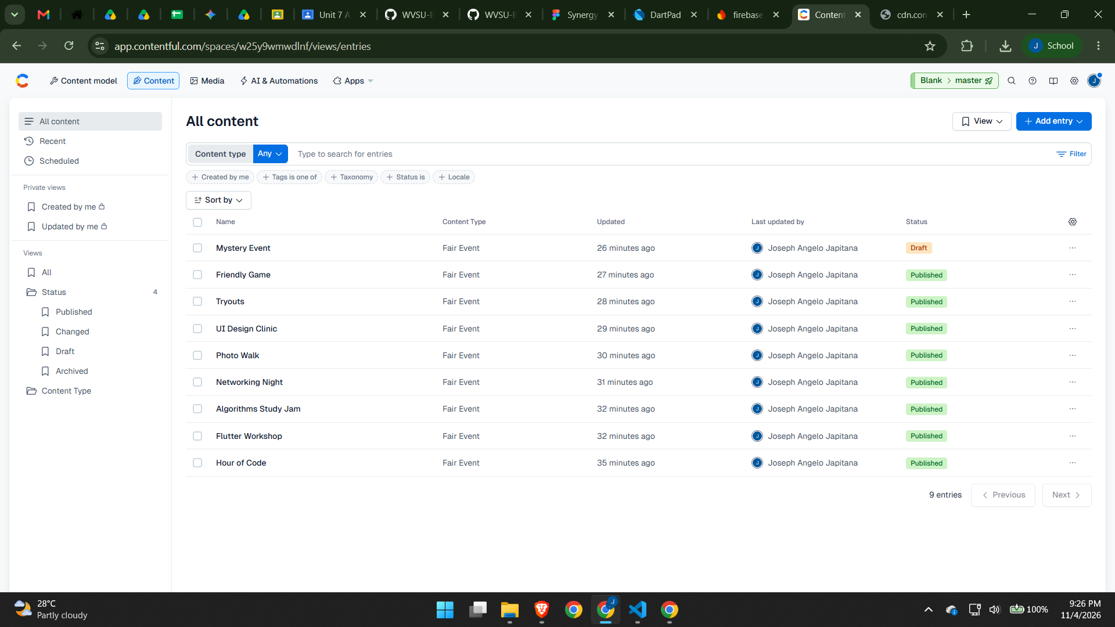
- Populate your data: 4 orgs, with at least 8 events. Mark one as cancelled, and leave one more as a draft. (5 points)

- Give the app read-only access, and test the URL.
CMS | Allow reading | Test this URL in a browser (or Postman)
Strapi | Settings > Users & Permissions > Roles > Public: tick find for Fair-event. (Or create an API token of type Read-only.) | http://localhost:1337/api/fair-events
Contentful | Settings > API keys > Add API key. Use the Content Delivery API access token. | https://cdn.contentful.com/spaces/SPACE_ID/environments/master/entries?content_type=fairEvent&access_token=TOKEN
Sanity | A public dataset needs no token. Under API > CORS origins, add http://localhost:* for flutter run -d chrome. | https://PROJECT_ID.apicdn.sanity.io/v2025-02-19/data/query/production?query=*[_type=="fairEvent"]

Provide a screenshot of the JSON from your URL below (5 points):
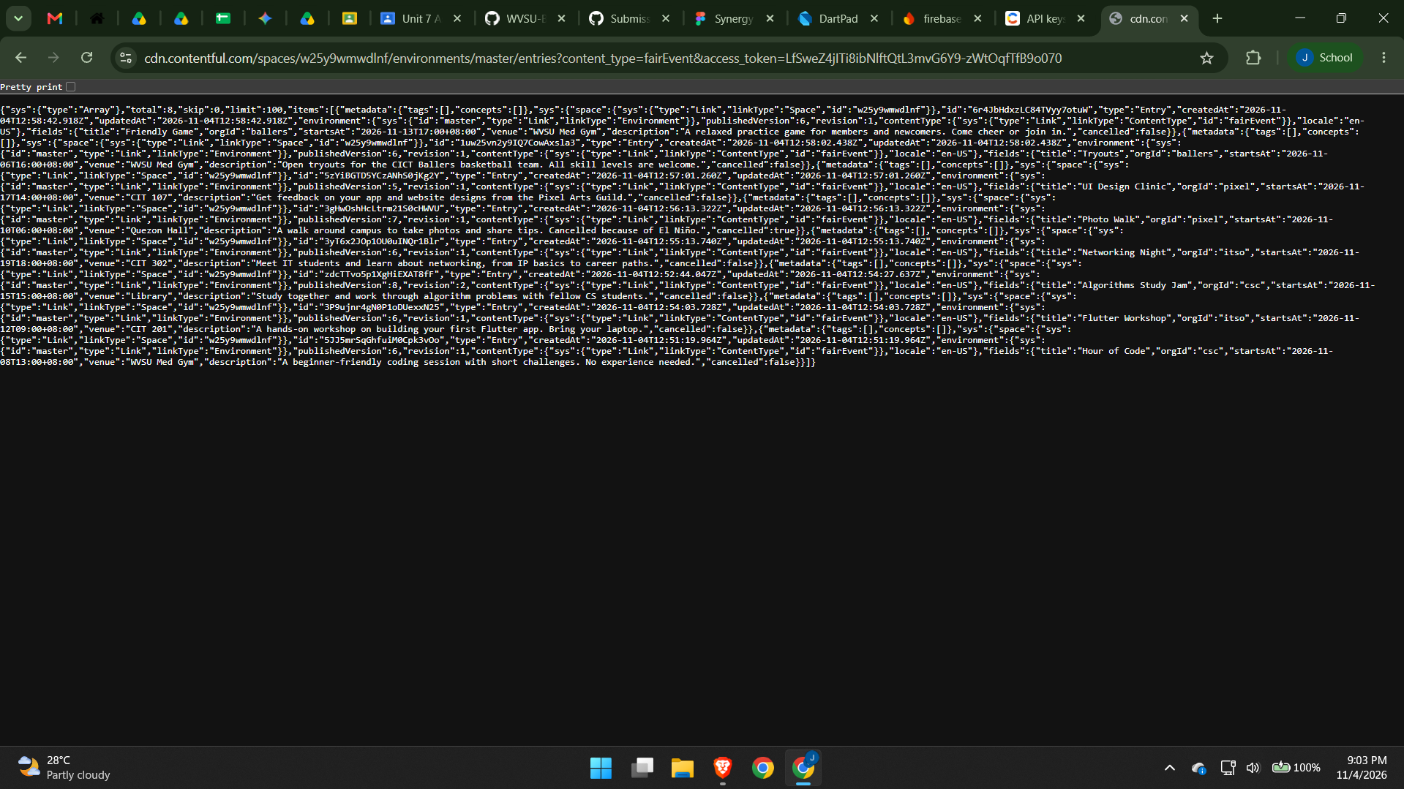

- Get the starter running. Perform the following steps, starting from copying the source code given in the GitHub link provided in the first page.

1. Inside it, run flutter create . (adds the platform folders), delete the generated test/widget_test.dart, then run flutter pub get (the starter adds the http package).
2. Run flutter run. Without a CMS the app uses the built-in sample events in sample_events.dart.
- Make a file cms.json next to pubspec.yaml with your values (see lib/config.dart), add cms.json to .gitignore, and run flutter run --dart-define-from-file=cms.json. The drawer shows where the events come from.
- Run your tests with flutter test test/events_test.dart test/<your cms>_source_test.dart. Delete the two CMS test files you did not choose (or keep one for the bonus).
{ "CMS": "strapi", "CMS_URL": "http://localhost:1337" }
{ "CMS": "contentful", "CMS_SPACE": "abc123xyz", "CMS_TOKEN": "your-delivery-token" }
{ "CMS": "sanity", "CMS_PROJECT": "zp7mbokg", "CMS_DATASET": "production" }

Testing Strapi on the Android emulator? Your computer is http://10.0.2.2:1337 there, and Android blocks plain http unless you add android:usesCleartextTraffic="true" to the <application> tag in android/app/src/debug/AndroidManifest.xml. Chrome (flutter run -d chrome) needs none of this.

What is in the starter
File | What it does | What you do
lib/models/fair_event.dart | NEW. One event, the same for every CMS | Read
lib/data/event_source.dart | NEW. The EventSource interface, CmsException and getJson() | TODO 1; E1, E4
lib/data/cms/strapi_source.dart  lib/data/cms/contentful_source.dart  lib/data/cms/sanity_source.dart | NEW. One source per CMS | TODO 2, 3 in the file of your CMS only; E3
lib/data/sample_events.dart | NEW. Built-in events, used with no CMS and in tests | Read only
lib/config.dart | NEW. Reads the --dart-define values and picks the source | Read; E2
lib/data/event_repository.dart | NEW. Keeps the last good list for offline use | TODO 4, 5; E5
lib/screens/events_screen.dart | NEW. The What's On tab | TODO 6 to 8; E6, E7
lib/widgets/event_tile.dart | NEW. One event in a list; shows the time in local time | TODO 9; E8
lib/screens/org_detail_screen.dart | The Events tab now reads the CMS | TODO 10
lib/screens/home_shell.dart | The NavigationBar, now with four tabs | TODO 11
lib/data/fair_data.dart | Officers and booth schedule (the events moved out) | Read only
test/ | events_test (everyone), one test file per CMS, org_fair_test (Part 2 still works) | Run

flutter analyze warns about unused code in the starter. Those warnings are clues: each goes away when its TODO is done. The two CMS files you did not choose keep their warnings; that is fine.
The finished app
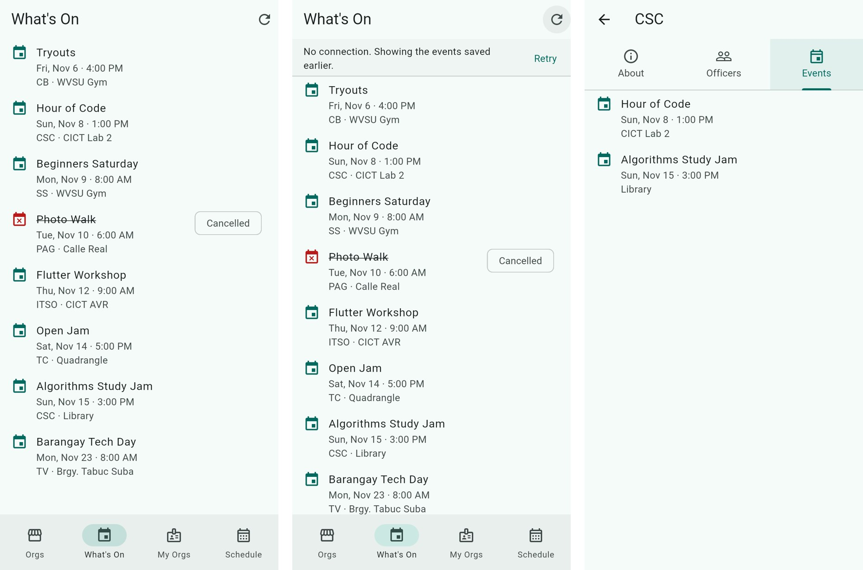
What's On from Strapi; the same list offline with the saved copy; one org's Events tab. The draft event never appears.

- Complete the TODOs (33 points). Each TODO is a comment in the code with a placeholder under it. Replace the placeholder with your code. 3 points each.
# | File | What to do | Slides (deck 7)
1 | event_source | Turn status codes into messages: 200 JSON, 401/403 token, 404 URL, 5xx try later | 45 to 48
2 | your CMS file | Build the request: URL, query parameters and the Authorization header | 41, 59 to 61
3 | your CMS file | Turn the JSON into a List<FairEvent>; missing fields become '' or false | 49, 60, 61
4 | event_repository | Save the events of every good load | 51 (caching)
5 | event_repository | If a load fails, return the saved copy with savedCopy: true | 67 question 4
6 | events_screen | _refresh: start a new load with setState and wait for it | 44, 50
7 | events_screen | Sort a copy of the list by startsAt | Unit 5 lists
8 | events_screen | A MaterialBanner with Retry when showing the saved copy | 46
9 | event_tile | Cancelled: line-through title, a "Cancelled" chip, the event_busy icon | 54
10 | org_detail_screen | The Events tab loads only this org's events (loadForOrg) | 62
11 | home_shell | Add the What's On page and its NavigationDestination | Unit 6 navigation

Evidence (Provide screenshots of the application to show that it is working):



